High Level Design (HLD)

**Face Mask Detector**

Revision No: 1.0

Last Date of Revision: 05/11/2023.

# Document Version Control-

|  |  |  |  |
| --- | --- | --- | --- |
| Date Issued | Version | Description | Author |
| **05/11/2023** | 1.0 | HLD – V- 1.0 | Mahesh. A |
|  |  |  |  |
|  |  |  |  |

**Contents -**

|  |  |
| --- | --- |
| **Description** | **Page**  **No.** |
| Document Version Control | 2 |
| 1. Introduction | 4 |
| 1.1 Necessity of HLD | 4 |
| 2. General Description | 4 |
| 2.1 Product Perspective | 4 |
| 2.2 Problem Statement | 4 |
| 2.3 Data Requirements | 4 |
| 2.4 The format would as the below mentioned sample | 6 |
| 2.5 Tools Required | 7 |
| 3. Design Details | 8 |
| 3.1 Process Flow- | 8 |
| 3.2 Model Training and Evaluation- | 8 |
| 3.3 Deployment Process | 9 |
| 3.4 Event Log | 9 |
| 3.5 Error Handling | 9 |
| 4 Performance- |  |
| 4.1 Reusability | 10 |
| 4.2 Application Compatibility | 10 |
| 4.3 Resource Utilization | 10 |
| 4.4 Deployment | 10 |
| 5 Conclusion |  |

# Introduction

* 1. **Necessity of HLD–**

The purpose of this document is to add the necessary information to the current project for Modelling and its coding. This can be treated as a user manual.

# General Description

* 1. **Product Perspective-**

This Facemask Detection is the project is based on the Deep learning Classifier which helps us to identify the facemask.

# Problem S-

To create the solution for the Facemask Identification

To detect whether he/she wore the mask or not

# Data Requirements-

The data requirements completely depend on the problem statement.

We need the data in the image format and the data of image name and its labels in and .csv format so that pandas readable format with the below mentioned details.

Attribute Information: (classes: Mask identified=1, No Mask identified=0)

|  |  |
| --- | --- |
| **file_name** | **labels** |
| without_mask. (1).jpg | 0 |
| without_mask. (10).jpg | 0 |
| without_mask. (100).jpg | 0 |
| without_mask. (101).jpg | 0 |
| without_mask. (102).jpg | 0 |

# The format would as the below mentioned sample

|  |  |
| --- | --- |
| **file_name** | **labels** |
| without_mask. (1).jpg | 0 |
| without_mask. (10).jpg | 0 |
| without_mask. (100).jpg | 0 |
| without_mask. (101).jpg | 0 |
| without_mask. (102).jpg | 0 |
| with_mask. (280).jpg | 1 |
| with_mask. (281).jpg | 1 |
| with_mask. (282).jpg | 1 |
| with_mask. (283).jpg | 1 |
| with_mask. (284).jpg | 1 |
| with_mask. (285).jpg | 1 |
| with_mask. (286).jpg | 1 |
| with_mask. (287).jpg | 1 |
| with_mask. (288).jpg | 1 |

* 1. **Tools Required-**

Python Programming language and the frameworks below mentioned are used to build the model.

* Pandas
* Numpy
* Matplotlib
* Seaborn
* OpenCV
* Tensorflow, Keras
* Joblib
* Sklearn
* Mysql
* Cassandra
* Gunicorn

1. VS code is used as the IDE
2. For visualization we user Mat plot library or sea born
3. We use local host for deploying the model
4. HTML/CSS for the front end development
5. Python flask used of the backend development
6. Git is used for version control
7. Docker is used of creation of model that works on any architecture.

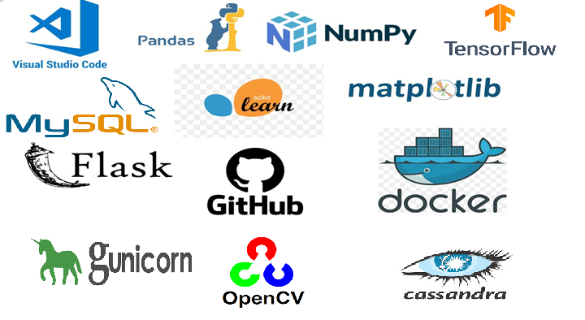

# Design Details

* 1. **Process Flow-**

Load data from the .csv file

Training / Validation on the dataset

DL model for prediction

Take necessary action.

Predictions on the test data

# Model Training and Evaluation-

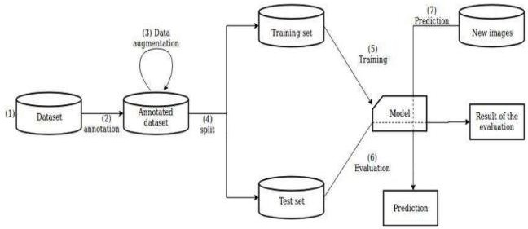

* 1. **Deployment Process:**

Start

Load Model

Get data from the front end form Html

Predicted Result

Make prediction

Process the data

# Event Log-

The system should log every event so the user will know the process that happens on the time.

The system should identify the different logs

The system should note down the logs for further usage Developer uses this data

# Error Handling-

By using the logs file all errors can be noted and find the solution for them by the developer.

.

# Performance-

This Facemask Identification model is used to generate the output whether One wore the facemask or not

# Reusability-

The code written should be reused without any problem.

# Application Compatibility-

We are using python as an interface.

# Resource Utilization-

When any task is preformed, it will use all the processing power to do the task assigned.

# Deployment-



1. **Conclusion-**

This DL project of Facemask detector which helps user to identify the whether the person wore the Facemask or not.